Aroids
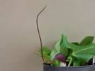 |  |  | Arisarum proboscidium ('Mouse Arum') is native to Italy, a miniature aroid with the flower resembling a mouse hiding in the foliage. It is hardy and grows best in a well drained position in part shade. |  |  | 3 tubers $5
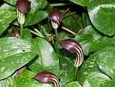 |  |  | Arisarum vulgare ('Cobra Lily') is a miniature aroid native to the Mediterranean region, with the flower resembling a cobra. It is hardy and grows best in a well drained position in part sun. Likes a dry summer. |  |  | 3 tubers $5
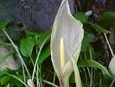 |  |  | Arum concinnatum has delicate cream flowers. It is hardy and grows best in a well drained position. Part sun to dappled shade. |  |  | Med $7 Small $4
 |  |  | Arum creticum is native to Crete, Greece. It has pale yellow flowers and is one of the few aroids with a nice scent. It is hardy and grows best in a well drained position in part shade. |  |  | Med $7 Small $4
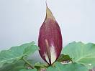 |  |  | Arum cyrenaicum has maroon-purple flowers (in mid September here). It is hardy and grows best in a well drained position. Part sun to dappled shade. |  |  | F/size $10 Med $7 Small $4
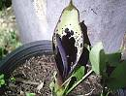  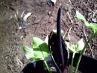 |  |  | Arum dioscoridis (native to the E. mediterranean area) has off white flowers spotted maroon-purple (appearing in mid October here). The flowers smell more like a manure heap than rotting meat. It is hardy and grows best in a well drained position. Part sun to part shade.  Arum dioscoridis Smithii (bottom) has a pinkish flush. |  |  | F/size $10  Med $7  Small $4
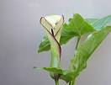 |  |  | Arum hygrophilum is native to Cyprus, Lebanon and Morocco. Best grown in a well-drained position in part shade. The cream flowers have a distinctive purplish edge. It flowers here in August/September. |  |  | F/size $10 Med $7 Small $4
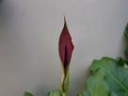 |  |  | Arum nigrum is native to the Balkans. Flower is sized between Arum orientale and Arum palaestinium. |  |  | Med $7 Small $4
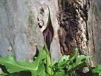 |  | Arum orientale is native to Cyprus and Central/Southern Europe. Best grown in a well-drained position in sun to part shade. The purple-black flowers are smaller than A. palaestinium.  It flowers here in September. |  |  | Med $7  Small $4
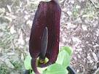 |  | Arum palaestinum (‘Black Calla’) syn A. sanctum (native to Israel, Lebanon and  Syria) has velvety purple-black flowers in mid spring. It is hardy and grows best in a well drained position. Full sun to dappled shade (the more sun the darker the flower). |  |  | Med $7  Small $4
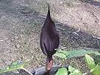 |  | Arum purpeospathum has purple-black flowers in mid spring. The foliage is edged purple. It is hardy and grows best in a well drained position. Full sun to dappled shade. |  |  | Med $7  Small $4
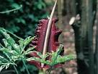 |  | Dracunculus vulgaris ('Dragon Arum') is native to the Central and Eastern Mediterranean region. The flower smells and is often called The ‘Dead Meat Lily’. Full to part sun in a well drained position. |  |  | Small $4
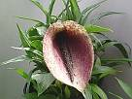 |  | Helicodiceros muscivorus 'Dragon's Mouth'  An interesting aroid from Southern Europe. ‘The flower looks as if a hairy tailed beastie has crawled inside and smells as if it has died’ was the description given when I first bought this aroid and is correct. |  |  | Med $7  Small $4
 |  | Other Bulbs
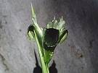 |  | Hermodactylus tuberose is an irid native to the Mediterranean. Likes full sun in an area dry in summer. |  |  | Med $7  Small $4
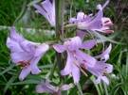 |  | Notholirion thompsonianum is a sweetly scented bulb native to the Himalayas’ and is monocarpic (the bulb dies after flowering) Full sun to part shade. |  |  | Med $5
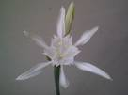 |  | Pancratium maritimum is native to the Mediterranean. It is hardy and grows best in a well drained position in sun to part shade. |  |  | Med $5
 | Daffodils
A selection of early white and cream hoop daffodils mostly from North Africa, drought hardy they perform best in full sun with a dry summer.
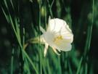 | bulbocodium cantabricus |  |  | 3 for $5
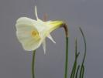 | bulbocodium Fyno |  |  | 3 for $5
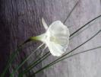 | bulbocodium Nylon |  |  | 3 for $5
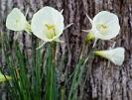 | bulbocodium Smarple |  |  | 3 for $5
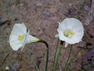 | bulbocodium tarlatan |  |  | 3 for $5
 | Perennials
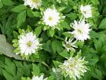 | Anemone bractea has a small double white flower surrounded by green or variegated leaf bracts. |  |  | 2 for $5
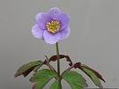 | Anemone nemorosa Blue is a tiny Anemone from Europe, plant in part-shade. |  |  | 2 for $5
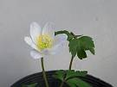 | Anemone nemorosa White |  |  | 2 for $5
 | South African Bulbs
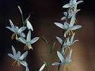 | Hesperanthe bachmanii is a tiny drought hardy bulb from the Cape Provence. The flowers open in the afternoon and are scented |  |  | 2 for $5
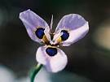 | Moraea aristata X villosa All moreas like a position that is DRY in summer in full sun to part shade. |  |  | $4ea
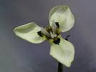 | Moraea tricuspidata |  |  | $4ea
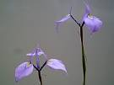 | Moraea tripetala |  |  | $4ea
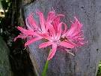 | Nerine Ethel’s Pink is a pink nerine with a pale centre. |  |  | $6ea
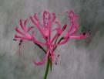 | Nerine filofolius is a miniature nerine with evergreen grass like foliage |  |  | 3 for $10
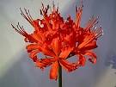 | Nerine sarniensis has orange-red flowers dusted with gold-dust. Nerines like a position in full sun to part shade, keep dry when dormant, water when leaves or flowers appear. |  |  | $5ea
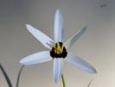 | Spiloxene capensis |  |  | $4ea
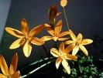 | Spiloxene orange |  |  | $4ea
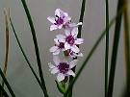 | Wurmbea stricta (Onixotis stricta) In the wild this bulb grows in full sun in swamps and pools and flowers appear late winter to early spring. |  |  | $5ea
This is a seasonal (Summer) catalogue only, please see www.raysunusualplants.com to view my full collection.

Please add Postage and Handling of $6 -under 500gm.

For orders over 500gm, postage will vary according to postcode.

Please note, I cannot send bulbs OVERSEAS, or to Tasmania or West Australia due to Quarantine regulations.

Please email me at raysunusualplants@yahoo.com.au
or phone 03 5473 4242 to place your order.

